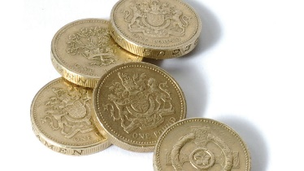
MONEY WEEK

Dear Parent/Guardian,
We are getting the chance to go shopping in school tomorrow. We can buy any of the following things:

- Chips = 80p
- Ice-cream = £1.00
- Drinks = 50p
- Donuts = 60p
- Sweets = 20p

We would love to give all of the children the chance to go shopping to practise the concepts we have been working on this week i.e.: adding amounts and working out change.
If you would like your child to experience ‘Shopping at Victoria PS’, please send in some money with them tomorrow.
Many thanks,
Mrs Loughins (Numeracy Co-ordinator)

