
Victoria Primary School
Carrickfergus

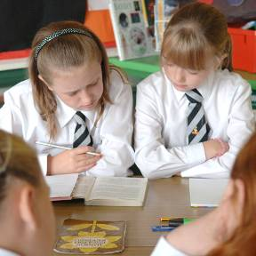
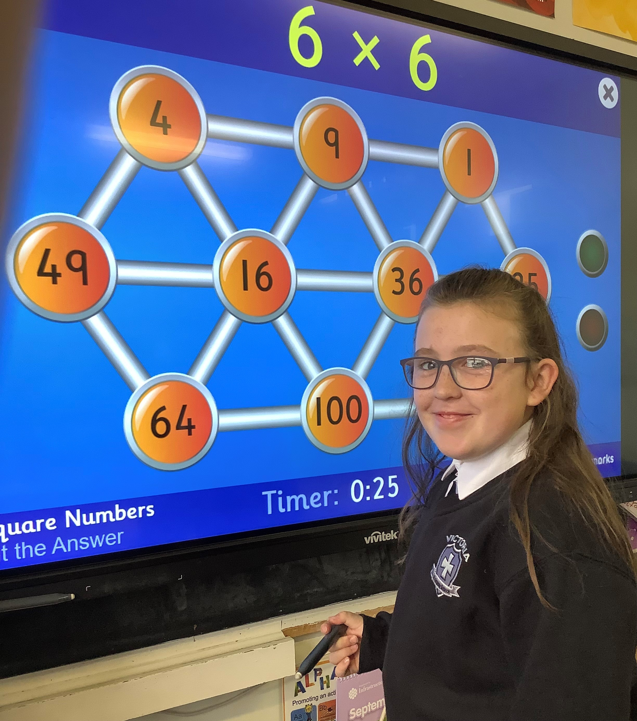

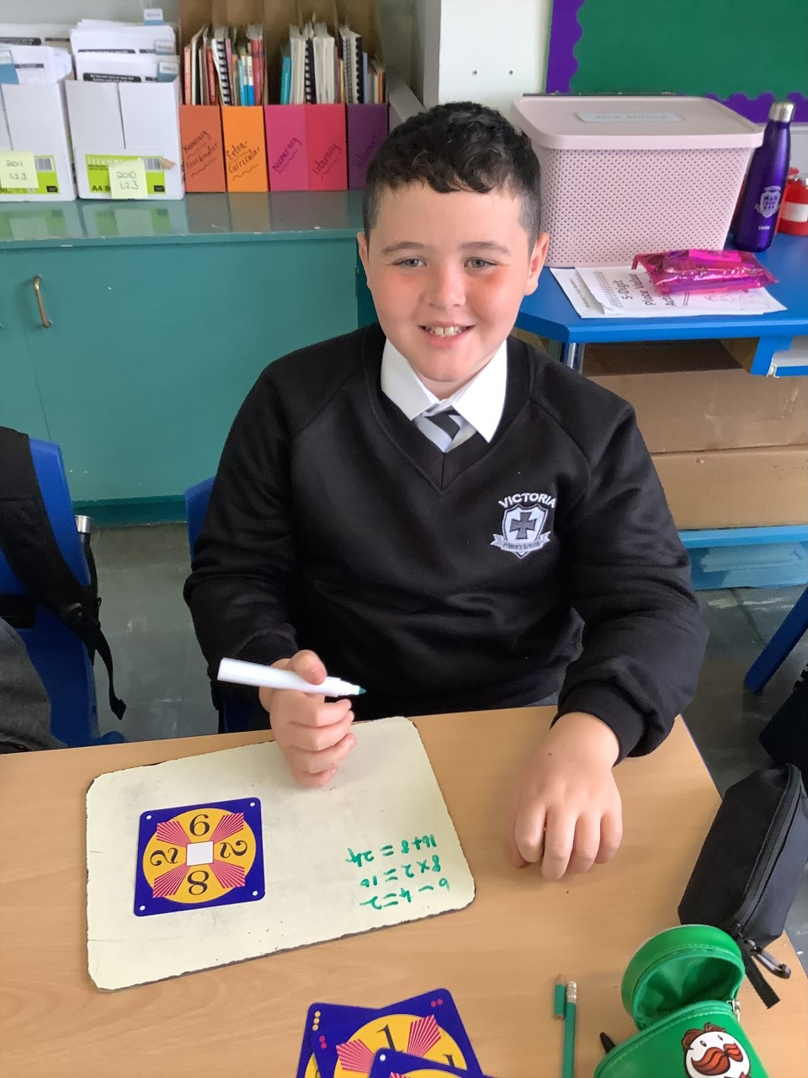
Parental
Information
Pack
Primary 7

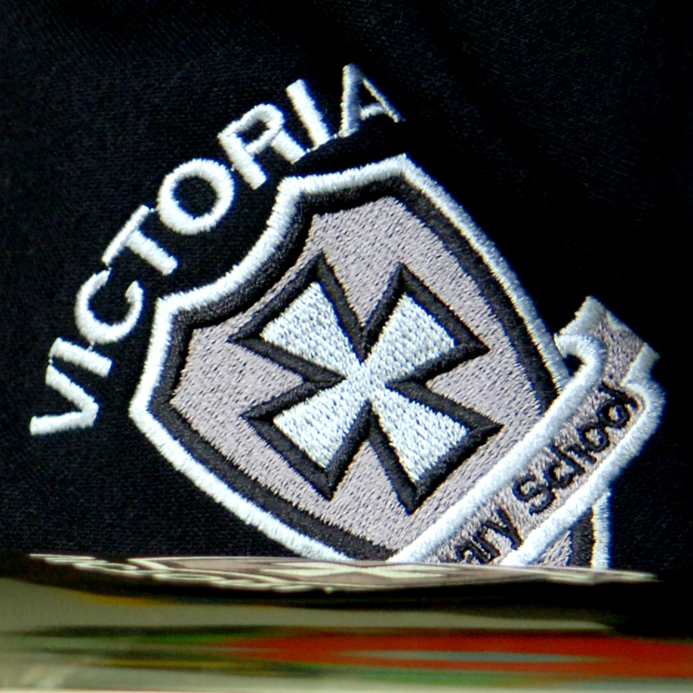


‘Working Together For Excellence’

Welcome to Primary 7 Victoria Primary School

Hello parents/guardians,

We are very pleased that your child has now started Primary 7 in Victoria Primary School. This information pack is designed to support you and your child throughout this year. Please read the information included and if you have any further questions please contact school on 02893351781. We look forward to meeting you at parental interviews and all other various school community events that take place between September and June. Thank you in advance for your support.

Contents

- Calendar information
- Information about Primary 7
- Maths topics
- Literacy topics
- World Around Us Topics

Calendar Information
2021/22

Please check the school website calendar for any additional dates.

Term Dates
August | Wed 25th – P2 – P7 return (half day and half classes – more info to follow)  Thurs 26th – P2 – P7 return (half day and half classes – more info to follow)  Fri 27th – P2 – P7 return (half day and full classes)  Mon 30th – School Closed (Public Holiday)
September | Wed 1st – P1 and Nursery children begin school. Specific dates and times will be communicated to individual parents.  Fri 24th – School Development Day (School Closed)
October | Mon 25th – School Development Day (School Closed)  Tues 26th – Fri 29th – Half Term (School Closed)
December | Tues 21st – School closes at 12pm for Christmas Holidays  Wed 22nd – School Development Day (School Closed)
January | Wed 5th – School reopens for all pupils in P2 – P7.  Nursery and P1 closed for Open Day.  Thurs 6th – School reopens for pupils in Nursery and P1.
February | Mon 14th & Tues 15th – School Development Day (School Closed)  Wed 16th – Fri 18th – Half Term (School Closed)
April | Fri 8th – School closes at 12pm for Easter Holidays  Mon 11th – School Development Day (School Closed)  Tues 12th – Fri 22nd – Easter Holidays (School Closed)
May | Mon 2nd – School Closed (Bank Holiday)  Mon 30th & Tues 31st – School Development Day (School Closed)
June | Wed 1st – Fri 3rd – (School Closed – mixture of holiday dates and bank holidays)  Fri 24th – P7’s last day at Primary School!  Thurs 30th – School closes at 12pm for Summer Holidays.
School Information

Principal Mr. Fulton
Vice-Principal Mrs. Kernaghan
Head of Foundation Mrs. Orr
and Key Stage 1
Head of Key Stage 2 Mrs Miskelly
Child Protection staff Mr Clarke/Mr Fulton /Mrs Addis/Mrs Kernaghan / Mrs Rodgers
Pastoral Care Mr Clarke
Special Education Needs Mrs Kernaghan
Chair of Governors Mrs Rodgers
Administrator Mrs Ritchie

School address Coronation Road
Carrickfergus
BT387EZ
02893351781
victoriaprimary@hotmail.co.uk

School Website www.victoriaprimary.org.uk

Parental information
Most parental information will be posted on the school website or sent out via our school app. (which is also accessible from SMART phones), including items such as canteen menu, holiday lists, monthly newsletters, policies and the welcome packs for each year group.

Queries
If you have a request or message Mrs Ritchie in the school office (02893351781) will pass on information to your child’s class teacher or make an appointment to talk to the staff member you require. Information regarding how to discuss concerns or complaints will be detailed on the school website or this information can be obtained from the school office.

Who To Talk To?
As you will be aware we are a large school. Mr Fulton (Principal) and Mrs Kernaghan (Vice Principal) are always willing to try to talk to as many parents / carers should any issues arise, however, this may not always be the case. It is important, to ensure that any query or concerns is dealt with quickly, that you follow the flow chart below in terms of who to contact first. Please do not be offended if Mrs Ritchie directs you to an alternative person on the list to make contact with first.
Contact Flow Chart

Class Teacher

Head of Key Stage
Mrs Orr for P1 – P4 or Mrs Miskelly for P5 – P7

Vice Principal
Mrs Kernaghan

Principal
Mr Fulton

Pastoral Care and Special Educational Needs (SEN)
The aim of all staff is to meet the needs of your child. If you have a concern about pastoral care, please call school and ask to speak with the class teacher of Mr Clarke (Pastoral Care Lead). Or if you would like to speak with someone about additional educational needs for your child please speak to the class teacher or Mrs Kernaghan.

Child Protection
Parents are given Child protection leaflets, E:Safety Acceptable Use leaflets, Pastoral care leaflets, What to Expect in each year leaflets and notes about praise, punctuality, attendance, uniform and photographs. The Child Protection Policy can be obtained via the school website and or through the school office. See below for how a parent can raise a concern.

How a parent/guardian can raise a concern

I have a concern about my / a child’s safety

I can talk to the class teacher in the Nursery Unit
or Primary School

If I am still concerned, I can talk to the Designated Teachers for Child Protection/Safeguarding
Mr J. Clarke
Mr Fulton /Mrs Kernaghan/Mrs P Addis

If I am still concerned, I can talk to the Principal
Mr C Fulton (Principal)

If I am still concerned, I can talk/write to the
Chairperson of the Board of Governors -
Mrs J Rodgers c/o Victoria Primary School
& Nursery Unit

At anytime, I can talk to a social worker at the Gateway Services or the PSNI Public Protection Unit, Newtownabbey.

Primary 7 Information

General information

The Primary 7 teachers this year are Mrs Foster in Room 14 and Mrs Miskelly in Room 13. Mrs Montgomery will also be working alongside the Primary 7 classes.

The aim of the teachers in Primary 7 is to meet the needs of your child. It is a busy year for pupils, staff and parents as we, together, cover a very broad and exciting curriculum. Your support and interest is greatly appreciated.
We have an extremely high attendance rate in Victoria and believe it is important to your child’s learning that you support full attendance and punctuality. Please ensure that your child has uniform clearly marked and that the uniform policy is adhered to (see website for details).
If you or your child has a question about school life or is unhappy about an issue, please speak to your class teacher or other relevant staff members as outlined in school information above.

School times
School starts at 9.10am and pupils can arrive in school from 8:50am. They are also welcome to attend our Breakfast Club in the school canteen from 8 – 8:50 am each morning at a small cost (contact school office).
Breaktime is from 10:30 – 10:45 and the pupils are encouraged to eat healthy break Monday – Thursday with a treat day on Fridays.
Lunchtime operates from 12:30 pm until 1pm and school finishes at 3pm each day except Friday when P7 children finish at 1:45pm.

The P7 week
Pupils will participate in Maths and Literacy lessons Monday – Friday. They will cover 5 topics over the year related to the ‘World Around Us’ (WAU). Please see below for details of these topic areas. They also participate in lessons in The Arts, PE, RE and PDMU (Personal Development and Mutual Understanding) much of which will directly relate to Maths, Literacy and WAU Learning Areas. Time will be spent each week using the Computer suite, school iPads and the school library.
P7 will go swimming in Carrick Leisure Centre as part of their PE curriculum approximately December – Easter.

Homework Pupils will be expected to undertake reading four nights per week, complete a written homework two nights a week, spellings and mental maths four nights per week, with revision on a Thursday. Homework could last up to 1 hour.

P7 Curriculum topics

Below are the Maths, Literacy and World Around Us topics to be covered in each half term in school. All pupils will be provided with a wide range of appropriate, differentiated reading material throughout the year.

Half Term | Maths Topic
September - October | - Place value - reading, writing, ordering, +, - numbers up to 1000000  - Addition ,subtraction, multiplication and division  - Rounding/approximating to nearest 10, 100, 1000  - X and dividing by 10, 100, 1000  - Function Machines  - Long multiplication using 2 and 3 digits  - Volume - Calculate volume of cuboids  - Triangular numbers sequence  - Square, Cube, prime numbers  - Factors trees and multiples  - 2D and 3D shapes and properties  - Lines of Symmetry  - Lines – perpendicular, parallel, oblique, diagonal  - Calculate perimeter and area  - Read and plot co-ordinates  - Algebraic equations  - Problem solving and mental maths
October – December | - Weight – Kg and g  - Interpreting data – tallies, graphs  - Negative number  - Fractions - Improper fractions  - + - Mixed numbers  - Finding fractions of amounts  - Forming equivalent fractions  - Conversions between fractions, decimals and %  - Decimals  - +, -, x, dividing to 2 decimal places  - Link %/fractions/decimals  - Tessellations  - Problem solving and mental maths
January – February | - Palindromes  - Consecutive numbers  - Circles – circumference, radius and diameter compass work  - Circle patterns and designs  - π  - Angles measuring, constructing and calculating  - Calculator work  - Coordinates in 4 quadrants  - Decimal addition/subtraction  - Pie Charts – interpret and construct  - Probability
February – April | - Calculate average (mean) mode, median and range of data  - Tally charts  - Line Graphs, Bar graphs, Bar line graphs – interpret/construct  - Time /distance graphs  - Time, timetables, duration  - Integers – negative numbers, temp  - Capacity  - Money – budgets, credit, debt, loans  - Holiday planning  - Currency conversions  - Class budget  - Problem solving and mental maths
April - June | - Parabolas  - Concentric circles  - 3D shape  - Rotational symmetry  - Problem solving and mental maths  - Logo – spider’s web  - Use scale in context  - Bearings
English Writing Topics
September - October | - Dairy Entry (Life on the Home Front)  - Character Profile
November – December | - Haiku poetry  - Class president campaign  - Queen Victoria research/facts
January – February | - Limericks  - Irish Famine Recipe  - Famine Letter and evaluations Victorian Board Games instructions/explanation  - Arguments for and against  - Working children debate
March – April | - Time travel stories  - Instructions for parachute experiment  - Climate Change debate
May - June | - Peer biographies  - Favourite memories of school P1 – P7
LITERACY  The following skills will be covered throughout all areas of Literacy over the course of the year. | The skills are:  - clarifying,  - understanding words,  - sequencing and retelling,  - making connections,  - comparing and contrasting, predicting,  - summarising,  - visualising,  - questioning,  - speculating and justifying,  - identifying the main idea,  - concluding,  - inferring,  - fact and opinion,  - cause and effect  - finding information.
WAU Topics

September – October | ‘The World at War’  - Causes and effects  - Anne Frank  - Leaders  - Life on the home front
November – December | ‘Victorians’  - Queen Victoria  - Famous Victorians  - Life in Victorian times
January – February | ‘Famine’  - The Irish famine  - Emigration  - Modern day famine
March – April | ‘Air’  - Parachutes  - Wind powered buggies
May - June | ‘Fair Enough’  - Fair Trade  - Journey of a fair trade product  - Rainforests

* Please note that the above is set out for general information only and pace of learning and variations in school life may necessitate some change to the delivery and timing of these Learning Areas.

