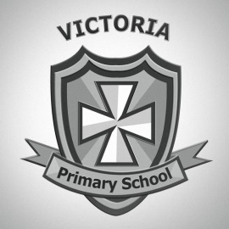
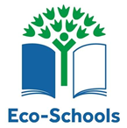

Green Day 2017
The Victoria Primary School Eco Committee has arranged our annual Green Day, (when we focus on an environmental issue), for March 17th. Your child should come to school wearing as much green as possible. A £1 donation is requested to support Eco Schools N.I. and our own school environment.
This year there will be an up cycling competition. Up cycling is finding a new use for an object for which there is no further use e. g. using an old bottle as a pen holder or plant pot. Children should bring their entries with them.
Pencils from recycled newspaper, pens from vegetables and rulers from packaging will be on sale that day.
The Eco Committee has arranged lots of other activities for that day.
_____________________________________
Each year as a school we participate in the Cash for Clobber scheme. Under this scheme the school receives money in return for used clothing, shoes etc. We are holding Cash for Clobber again this year. We would appreciate it if you could donate any old clothes, towels, curtains shoes etc. that you no longer want or wear. All of your donations will go straight to Cash for Clobber where they will either to be sent to people who do not have as many clothes as us, or recycled. Please put unwanted clothing shoes curtains etc. into a bag and leave in school between 16th and 20th March. We hope you understand that this is for a good cause and we would be grateful for your help.
Thank you,
The Eco Committee

